MS SQL SERVER
Standard Operating Procedures
(SOP)
SQL Server 2008- new features
Submitted to



BY



CIS, Wipro Limited

Document Details
Project Name | Innogy SE
Account | CIS
IT Component/Application Title | SQL Server 2008- new features
Current Version | 1.5
List of Contributors | Pradipkumar Kansara, Kiran Bhalekar, Ayushi Gautam, Sivakumar Goud, Nanda Kishore Reddy
Customer Contact Information

Version History
(All revisions made to this document must be listed in chronological order. All revisions must be approved. Review and Approval can be done by an internal source or by the customer)
Version | Date of Revision | Description | Author | Reviewed By | Approved By
1.0 | 29-08-2015 | Initial Draft | Kiran Bhalekar | Pradipkumar Kansara | Mahesh Keshatwar
1.1 | 04-09-2015 | Document Completed | Kiran Bhalekar | Pradipkumar Kansara | Mahesh Keshatwar
1.2 | 21-08-2016 | Updated document to standard format | Kiran Bhalekar | Pradipkumar Kansara | Mahesh Keshatwar
1.3 | 17-05-2017 | Wipro and Innogy Logo changed | Ayushi Gautam | Pradipkumar Kansara | Mahesh Keshatwar
1.4 | 14-09-2017 | Updated document to Wipro Standard format with header and footer | Sivakumar Goud | Pradipkumar Kansara | Santosh Badiger
1.5 | 17-11-2018 | Updated the content | Nanda Kishore Reddy | Pradipkumar Kansara | Santosh Badiger

Document Distribution List
S.No | Name and Company | Purpose
1 | RWEIT-SQLDBA | Document is useful for understanding about SQL server 2008 new features.
2

Table of Contents

1. Purpose 3
2. Scope 3
3. Introduction / Overview 3
4. DBA NEW FEATURES 4
1. Activity Monitor : 4
2. Object Explorer Details : 5
3. Script Data from the database : 7
4. Backup Compression 7
5. Central Management Servers 8
6. Missing Index Details in Querry Execution Plan. 10
7. Multi Server Querry 13
8. Power Shell Integration. 15
9. Sql Server Audit: 20
Auditing Specifications 21
Server Audit Specification 22
Database Auditing Specification 25
10. Contacts 26

Purpose

The purpose of this document is to highlight the new features available in SQL Server 2008 for day to day activity.

Scope

The scope of the document is to provide an insight to the DBA for the monitoring and maintaining databases for day to day activity.

Introduction / Overview

Microsoft SQL Server 2008 provides a number of enhancements and new functionality, building on previous versions. Administration, database maintenance, manageability, availability, security, and performance, among others, all fall into the roles and responsibilities of the database administrator.
This article highlights some of the new features of SQL Server 2008 that can help DBAs fulfill their responsibilities.

DBA NEW FEATURES

Activity Monitor :

SQL Server 2008 Activity Monitor consolidates the general information about what processes are executing and where the problem may be by detailing running and recently executed processes, graphically. The display gives a high-level view and the ability to drill down on processes and view wait statistics to help understand and resolve problems.
To open up Activity Monitor, just right-click on the registered server name in Object Explorer and then click Activity Monitor. It provides an overview section producing output similar to Windows Task Manager and drilldown components to look at specific processes, resource waits, data file I/Os, and recent expensive queries, as

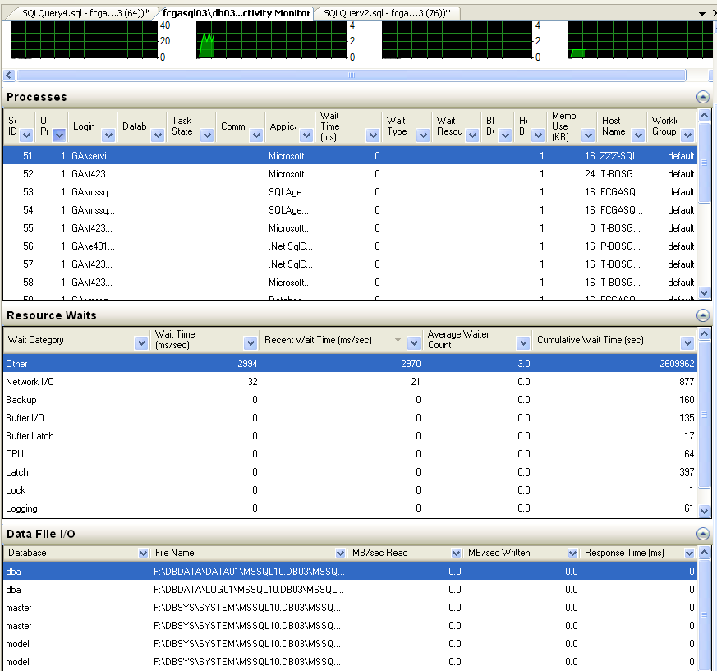
Figure 1: Acivity Monitor

Activity Monitor can also be used to perform the following tasks:
- We can Pause and resume Activity Monitor with a simple right-click to save a particular point-in-time for further investigation without it being refreshed or overwritten. For manual refresh, if we expand, or collapse a section, the data will be refreshed.
- Right-click a line item to display the full query text or graphical execution plan via Recent Expensive Queries.
- Execute a Profiler trace or kill a process from the Processes view. Profiler events include RPC:Completed, SQL:BatchStarting, and SQL:BatchCompleted events, and Audit Login and Audit Logout.
Activity Monitor also provides the ability to monitor activity on any SQL Server 2005 instance, local or remote, registered in SQL Server Management Studio.

Object Explorer Details :

In SQL Server 2008 there have been new enhancements made to the Object Explorer Details window. The detailed information displayed in depends on the object selected within the Object Explorer. Open the Object Explorer Details window in SQL Server 2008 by pressing F7 key or selecting “Object Explorer Details” option from the View menu. As shown in the screen shot the information related to all the Databases is displayed. From the Drop down menu we can get the desired property details like, Policy Health State, Recovery Model, last backup date, Collation, Owner, etc..

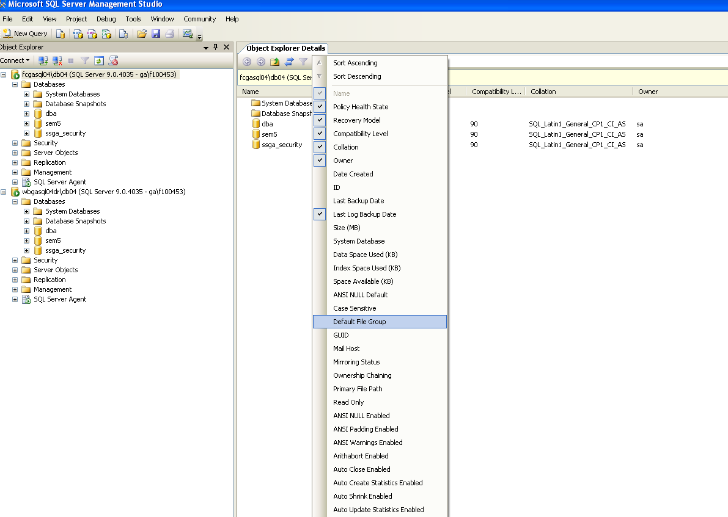
Figure 2: Object Explorer Details

Script Data from the database :
Generate SQL Server Scripts Wizard has an option to “Script data” which canbe set to “true” as shown in the below mentioned screen shot and this would help us get the insert commands too with the table and other views,stored procedure script. This can act as substitute for export/import wizard for small databases.
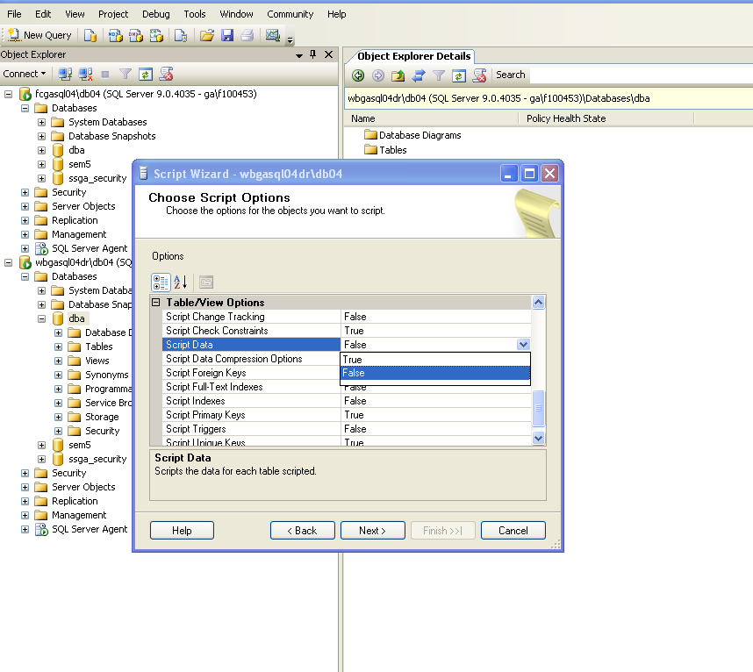
Figure 3: Script data

Backup Compression
This feature has long been a popular request of DBAs for SQL Server. The wait is finally over, and just in time! Many factors, including increased data retention periods and the need to physically store more data have contributed to the recent explosion in database size. Backing up a large database can require a significant time window to be allotted to backup operations and a large amount of disk space allocated for use by the backup file(s).
With SQL Server 2008 backup compression, the backup file is compressed as it is written out, thereby requiring less storage, less disk I/O, and less time. In lab tests conducted with real customer data, we observed in many cases a reduction in the backup file size between 70% and 85%. Testing also revealed around a 45% reduction in the backup and restore time. It is important to note that the additional processing results in higher processor utilization.
The compression is achieved by specifying the WITH COMPRESSION clause in the BACKUP command or by selecting it in the Options page in the Back Up Database dialog box. To prevent having to modify all existing backup scripts, there is also a global setting to enable compressing all backups taken on a server instance by default. (This setting is accessed by using the Database Settings page of the Server Properties dialog box or by running sp_configure with backup compression default set to 1.) While the compression option on the backup command needs to be explicitly specified, the restore command automatically detects that a backup is compressed and decompresses it during the restore operation.
Backup compression is a very useful feature that can help the DBA save space and time
This feature is available in sql server 2008 enterprise and developer edition.

Central Management Servers
The Central Management Servers implementation can be accessed via the Registered Servers component in SQL Server Management Studio. This allows DBA to perform a number of administrative tasks on SQL Servers within the environment, from a single management console.
Central Management Servers allow the DBA to register a group of servers and apply functionality to the servers, as a group, such as:
- Multiserver query execution: A script can now be executed from one source, across multiple SQL Servers, and be returned to that source, without the need to distinctly log into every server. This can be extremely helpful in cases where data from tables on two or more SQL Servers needs to be viewed or compared without the execution of a distributed query. Also, as long as the syntax is supported in earlier server versions, a query executed from the Query Editor in SQL Server 2008 can run against SQL Server 2005 and SQL Server 2000 instances as well.

- Import and evaluate policies across servers: As part of Policy-Based Management (another new SQL Server 2008 feature discussed in this article), SQL Server 2008 provides the ability to import policy files into particular Central Management Server Groups and allows policies to be evaluated across all of the servers registered in the group
- Control Services and bring up SQL Server Configuration Manager: Central Management Servers help provide a central place where DBAs can view service status and even change status for the services, assuming they have the appropriate permissions

- Import and export the registered servers: Servers within Central Management Servers can be exported and imported for use between DBAs or different SQL Server Management Studio instance installations. This is an alternative to DBAs importing or exporting into their own local groupings within SQL Server Management Studio.

Please find the screenshots below to export the registered servers list.
The permissions are enforced via Windows authentication, so a user might have different rights and permissions depending on the server registered within the Central Management Server group

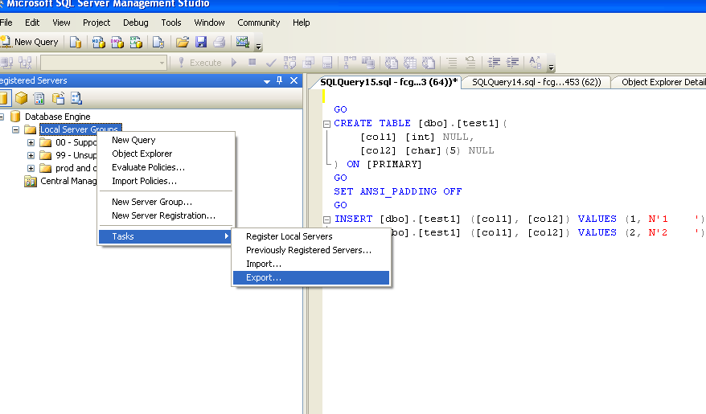
Figure 4:Export Registered server

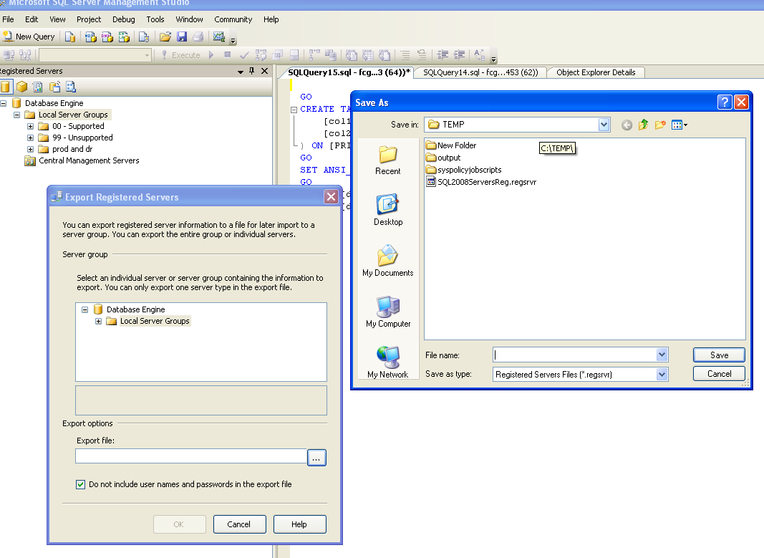
Figure 5:Path allocation

Missing Index Details in Querry Execution Plan.
In SQL Server 2008 Management Studio there is an feature to identify missing indexes when executing the TSQL code within the Query window. To use this feature click “CTRL+M” or select “Include Actual Execution Plan” option from the Query menu before executing the query.
This option provides an actual individual plan as shown in the screen shot below.

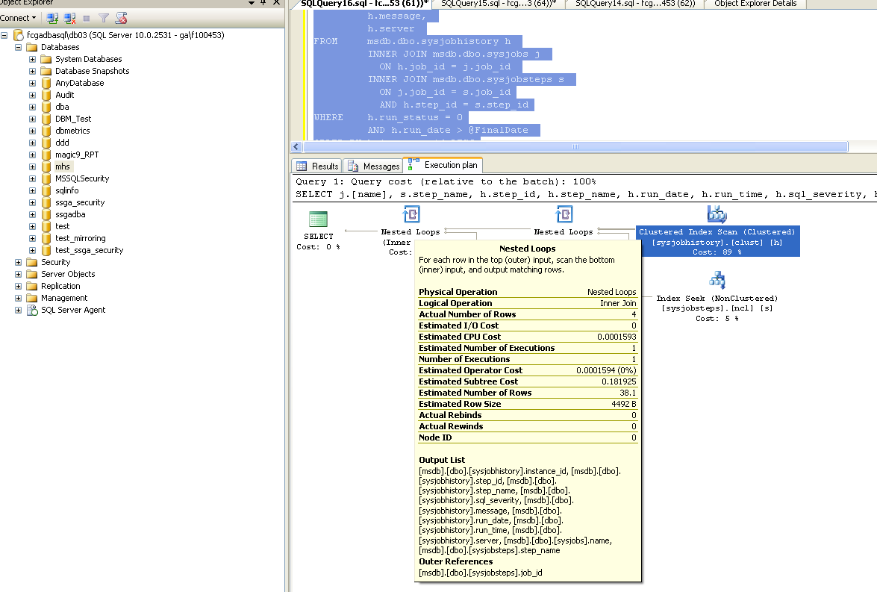
Figure 6: Actual Querry Execution Plan
This feature is useful as it displays the missing index information and also provides the script which can be used to create the missing index. Generate the script by right clicking Missing Index and then by selecting Missing Index Details…. option from the drop down as shown in the below Screen shots.
Note : the below screen shot is taken from web.

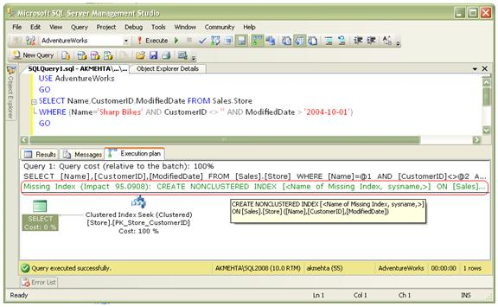
Figure 7: Missing Index Hint

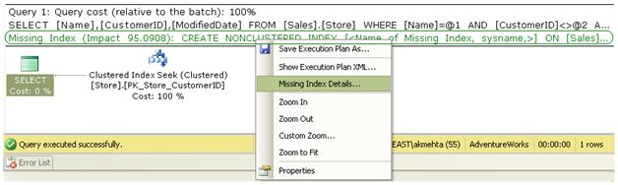

The below mentioned querry is generated as part of the above actions.
/*
Missing Index Details from SQLQuery1.sql – Test\test.AdventureWorks (test (55))
The Query Processor estimates that implementing the following index could improve the query cost by 95.0908%.
*/
/*
USE [AdventureWorks]
GO
CREATE NONCLUSTERED INDEX [<Name of Missing Index, sysname,>]
ON [Sales].[Store] ([Name],[CustomerID],[ModifiedDate])
GO
*/
If interested in accepting the suggestion given by SQL Server 2008, then modify the script by providing an appropriate name for the index and then press F5 to create the index.
USE [AdventureWorks]
GO
CREATE NONCLUSTERED INDEX [IX_Name_Sales_Store]
ON [Sales].[Store] ([Name],[CustomerID],[ModifiedDate])
GO

Multi Server Querry

SSMS 2008 has a feature to run a query on different servers from one query editor window. We need to register all the servers and once they are registered Right Click on server group name and click New Query as shown in the image below. We can also track on the number of servers where the user is connected as shown in pink colour at the left side bottom.

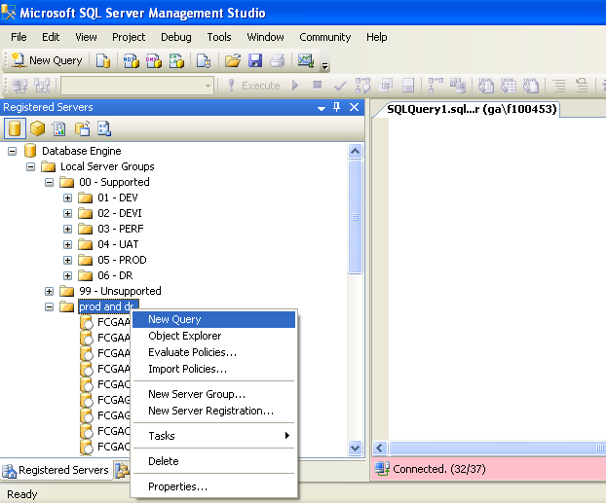
Figure 8:Multi server Query

As shown below we can get the result of the queries run with the servername.

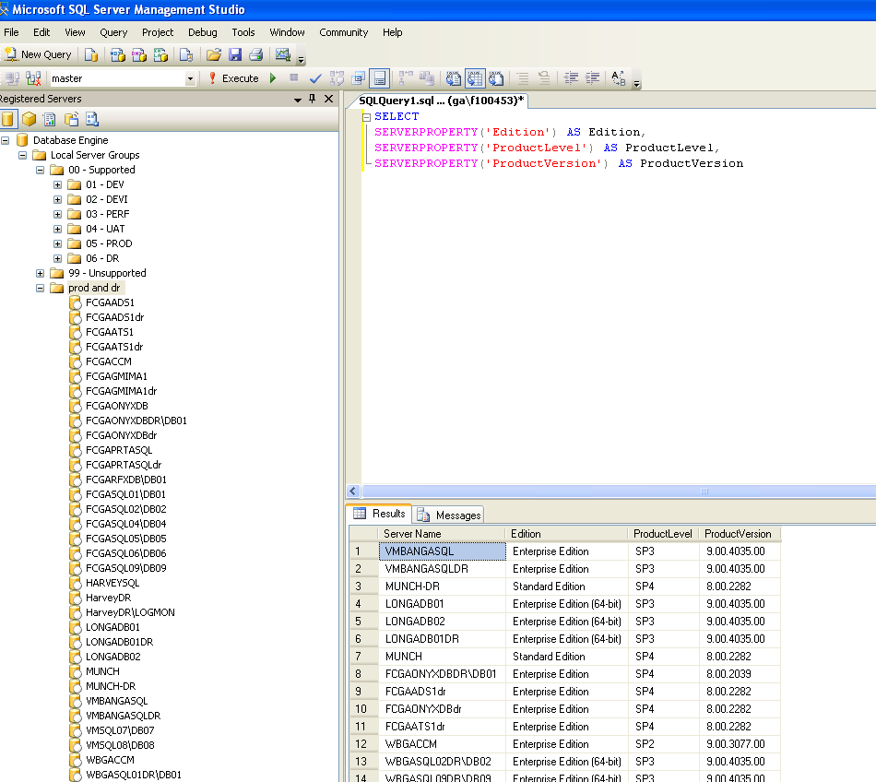
Figure 9:Output

Power Shell Integration.

The SQL Server 2008 comes integrated with powershell. Powershell, a scripting shell that lets the administrator and developers automate server administration and maintenance. The Windows Power Shell language supports more complex logic than Transact-SQL scripts, giving SQL Server administrators the ability to build robust administration scripts such as backup, Shrink log file, reorganize indexes both online and offline etc.

For Ex.

# Setting path for the powershell Log

$log = "F:\backup\backup.log"

# Logging started

Start-Transcript -path $log

# Importing the SMO'S

[System.Reflection.Assembly]::LoadWithPartialName('Microsoft.SqlServer.SMO') | out-null
[System.Reflection.Assembly]::LoadWithPartialName('Microsoft.SqlServer.SmoExtended') | out-null

# function to raise error

Function RaisError ([string]$ErrMsg){
write-host $ErrMsg -f red
$error.clear()
}
# Getting the filename from Text file

foreach ($computername in Get-Content "F:\Backup\Servers.txt")
{

Write-Host "The computer is $computername "

$s = new-object ('Microsoft.SqlServer.Management.Smo.Server') $computername
$bkdir = $s.Settings.BackupDirectory

$bkdirs=$bkdir -replace ':','$'

$srv = $computername -replace '\[',''

$srvs=$computername.substring(0, $computername.indexof("\"))

$bkdirss= "\\" + $srvs + "\" +$bkdirs

Write-Host "The databases are $srvs "
Write-Host "The databases are $bkdirss "

# Checking the existence of directory on Server and deleting files whose creation date is older than 1 day

if (Test-Path $bkdirss)

{

$Now = Get-Date
$LastWrite = (get-date).addDays(-01)
Write-Host "The lastwarite is $LastWrite and !"
$Files = get-childitem $TargetFolder -include *.bak -recurse |Where {$_.LastWriteTime -le "$LastWrite"}

Write-Host "The File is $Files "

# Removing the files one by one

foreach ($File in $Files)

{
if($files.count -ge 1)
{

Remove-Item $File | out-null
}

}

}
else
{
RaisError "`t`n Unable to find the location "
}

$dbs = $s.Databases

Write-Host "The databases are $dbs "

# Taking the backups of the databases

$dbs | foreach-object{
$db = $_
if ($db.IsSystemObject -eq $False -AND $db.status -eq "Normal" -AND $db.IsMirroringEnabled -eq $False)

{
$dbname = $db.Name
$dt = get-date -format yyyyMMddHHmmss
$dbbk = new-object ('Microsoft.SqlServer.Management.Smo.Backup')
$dbbk.Action = 'Database'
$dbbk.BackupSetDescription = "Full backup of " + $dbname
$dbbk.BackupSetName = $dbname + " Backup"
$dbbk.Database = $dbname
$dbbk.MediaDescription = "Disk"
$dbbk.Initialize = 1
$dbbk.Devices.AddDevice($bkdir + "\" + $dbname + "_db_" + $dt + ".bak", 'File')
$dbbk.SqlBackup($s)
if (!$error){
write-host "`t`nDatabase $Dbname backed up successfully" -f green

}

else {
RaisError "`t`nDatabase $Dbname has an issue . $error"
}

}

}

}

# Logging stopped
Stop-Transcript

The above script can be used to take back up of the databases for the instances mentioned in the “servers.txt” file.

The power shell can be started as shown below.
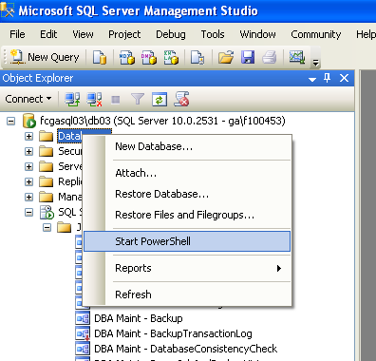

Figure 10:Start Power Shell

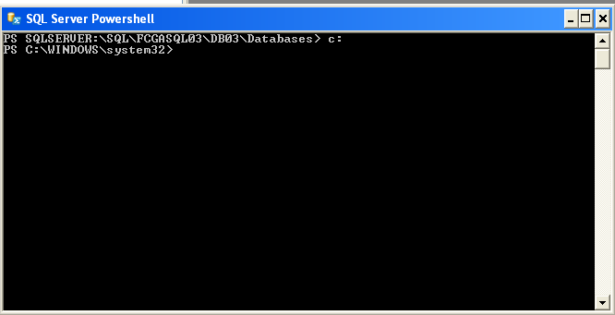
Figure 11: Powershell command Prompt

As shown above we can build different scripts for the administration of the databases.

Sql Server Audit:

This is a new feature available in SQL Server 2008.

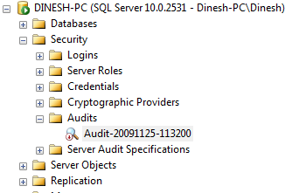
Figure 12: Audit Node
By right clicking Audit and selecting New Audit, we can create a new audit as below:
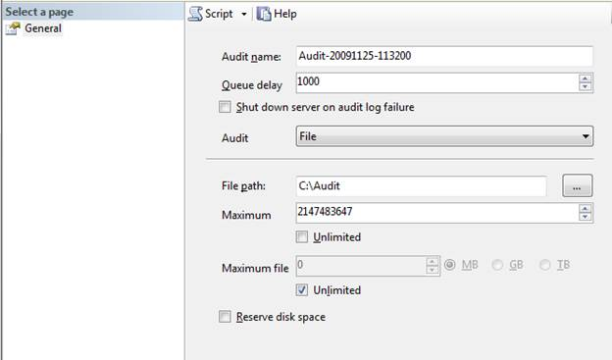
Figure 13: Audit Creation

We can specify the various options as shown in the screen above.

Queue delay : It is the amount of time that can elapse in milliseconds before audit actions are forced to be processed. A value of 0 indicates synchronous delivery

Shut down server on audit log failure: will shut down the SQL Server.

Audit :Here you an specify the destination file. There are three options for the destination; File, Security Log and Application Log.

The audit information in the above scripts are saved in the sys.server_audits system table

Auditing Specifications

Now we have created the audit location, we need to create the auditing specifications. There are two types of auditing specifications.
1. Server Audit Specification
2. Database Auditing Specification

Server Audit Specification
Only one Server Audit Specification can be created for one audit.
Server audit will focus on the server level events such as logon/logoff operations, database backup/restore, database maintenance operations, server objects changes, permission changes etc.

These are several frequently used Server Audit Specifications groups which are listed in following table.

Action group name | Description
SUCCESSFUL_LOGIN_GROUP | Indicates that a principal has successfully logged in to SQL Server.
LOGOUT_GROUP | Indicates that a principal has logged out of SQL Server.
FAILED_LOGIN_GROUP | Indicates that a principal tried to log on to SQL Server and failed.
LOGIN_CHANGE_PASSWORD_GROUP | This event is raised whenever a login’s password is changed by way of ALTER LOGIN statement or sp_password stored procedure
APPLICATION_ROLE_CHANGE_PASSWORD_GROUP | This event is raised whenever a password is changed for an application role.
SERVER_ROLE_MEMBER_CHANGE_GROUP | This event is raised whenever a login is added or removed from a fixed server role. This event is raised for the sp_addsrvrolemember and sp_dropsrvrolemember stored procedures.
DATABASE_ROLE_MEMBER_CHANGE_GROUP | This event is raised whenever a login is added to or removed from a database role.
BACKUP_RESTORE_GROUP | This event is raised whenever a backup or restore command is issued.
DBCC_GROUP | This event is raised whenever a principal issues any DBCC command.
SERVER_OPERATION_GROUP | This event is raised when Security Audit operations such as altering settings, resources, external access, or authorization are used.
DATABASE_OPERATION_GROUP | This event is raised when operations in a database, such as checkpoint or subscribe query notification, occur. This event is raised on any database operation on any database.
DATABASE_CHANGE_GROUP | This event is raised when a database is created, altered, or dropped.
DATABASE_PRINCIPAL_CHANGE_GROUP | This event is raised when principals, such as users, are created, altered, or dropped from a database.
SERVER_PERMISSION_CHANGE_GROUP | This event is raised when a GRANT, REVOKE, or DENY is issued for permissions in the server scope, such as creating a login.
SERVER_OBJECT_PERMISSION_CHANGE_GROUP | This event is raised whenever a GRANT, REVOKE, or DENY is issued for a server object permission by any principal in SQL Server.
DATABASE_PERMISSION_CHANGE_GROUP | This event is raised whenever a GRANT, REVOKE, or DENY is issued for a statement permission by any principal in SQL Server
we can create Server Audit Specifications from either SSMS or T-SQL.
In SSMS, there is new node called Sever Audit Specifications, where we can right click and create the new Server Audit Specifications.
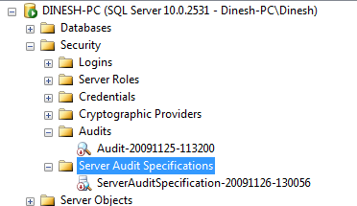
Figure 14: Audit specification
we get the following screen after selecting new Server Audit Specifications.
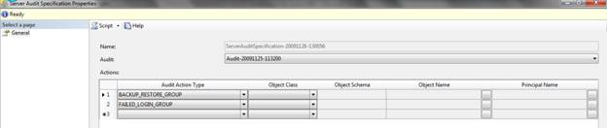
Figure 15: Audit specified
In this, select audit specification name and the audit name.
After that you have to define Audit groups. The Server Audit Specification must then be Enabled. Altering and dropping audit specifications is done in a similar manner to Audits.

Viewing Audit Results
Right click the relevant Server Audit and select View Audit Logs , the below screen should be visible.
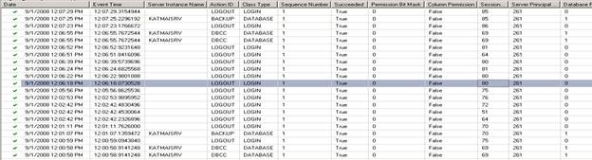

Database Auditing Specification
Database auditing is to audit database specific activities. Similar to Server Audit Specification there is a new Database Auditing Specification node below the DatabaseName -> Security node.
By right clicking and select new Database Auditing Specification, you can create a Database Auditing Specification. Next select an appropriate audit action group. The following list gives the commonly used auditing groups.
SELECT | This event is raised whenever a SELECT is issued.
UPDATE | This event is raised whenever an UPDATE is issued.
INSERT | This event is raised whenever an INSERT is issued.
DELETE | This event is raised whenever a DELETE is issued.
EXECUTE | This event is raised whenever an EXECUTE is issued.
REFERENCES | This event is raised whenever a REFERENCES permission is checked.
Apart from the above list, all the groups in the Server Audit Specifications which starts with DATABASE are available. The main difference is that, Database Auditing Specification is for a given database while Server Audit Specification is for an entire server.

